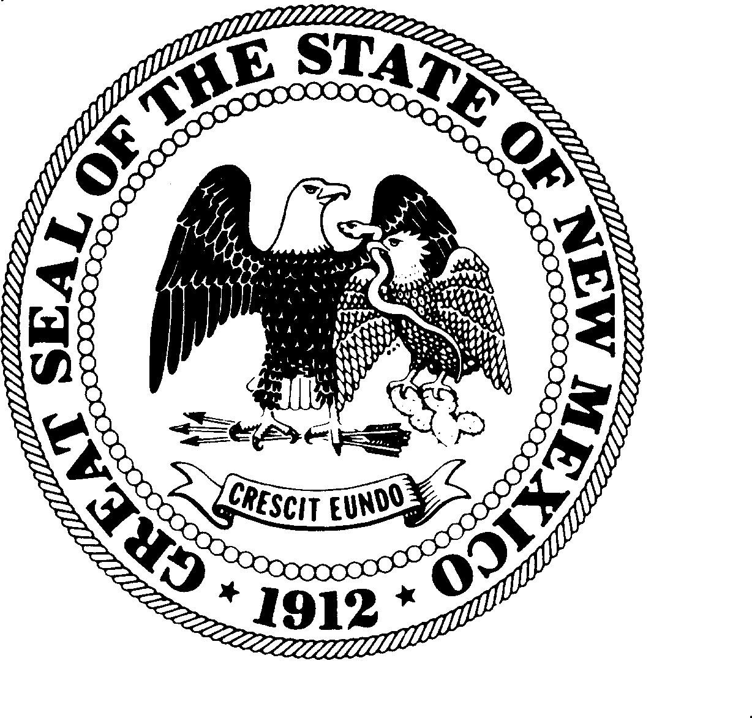
Arturo Archuleta
Commissioner

Oscar Butler Vasquez
Commissioner

Andrea La Cruz-Crawford
Commissioner

Monica Rodríguez
Commissioner

Heather Romero
Commissioner

Michelle Luján Grisham
Governor

Community Governance Attorney Commission

Regular Commission Meeting
In-Person + Virtual
UNM Continuing Education – South Building – RM 207
1634 University Blvd NE – Albuquerque
Zoom Meeting I.D. – 952 5370 1712
June 29, 2026 – 10:00 AM

Agenda

- Call to Order – Roll Call
- Introduction of Guests
- Approval of Agenda
- Approval of Meeting Minutes from May 8, 2026 Meeting
- Discussion and Possible Action on Applicant Selection Guidelines
- Closed Executive Session pursuant to NMSA 1978, 10-15-1(H)(2) & (4) for discussions related to review of student applications for 26/27 Academic School Year and student interviews.
- Discussion and Possible Action on Community Governance Attorney Program Participant Selection.
- Discussion and Possible Action on CGAP Budget
- Discussion and Possible Action on pending Contracts/MOUs
- Public Comments – discussion only
- Miscellaneous Announcements
- Date and Location of Next Commission Meeting
- Adjournment

